Team 5- Assignment 7.1
Final Paper

Intro:
After being introduced to Free Joint Motion in Week 1 of the course, we were excited to do additional research and see how we could help them break into the United States Market. Free joint motion’s patent pending product is unlike any other ankle rehabilitation device on the market. While there are many options for this type of injury, none of them are as advanced as Free Joint Motion’s. With that being said, Free Joint Motion is a startup company and there are several factors a company must take into consideration when attempting to enter the United States Market. They are facing a lack of funding which is necessary for research and development, they also need to gain insight on what types of certifications and training will be necessary in the US. In our deliverable, we would like to provide the clients with a thorough CAGE and Industry Analysis as well as recommendations for a specific target market, funding options, barriers to entry and a pricing model. We hope that they are satisfied with these recommendations and that it will aid their company in expansion.

Cage Analysis:
As mentioned in Week 1, the client is originally from Argentina and they are living in Florida, USA. The client’s country compared to the United States have some differences, but not much and entering the American market is what interests them to have the opportunity of success. Looking over the CAGE analysis over the weeks, we found that the main obstacles to overcome would be the Cultural and Administrative distances.
Throughout the CAGE Analysis, there are some similarities and differences between Argentina and USA. The cultural, administrative, geographic, and economic difference between Argentina and USA is low.

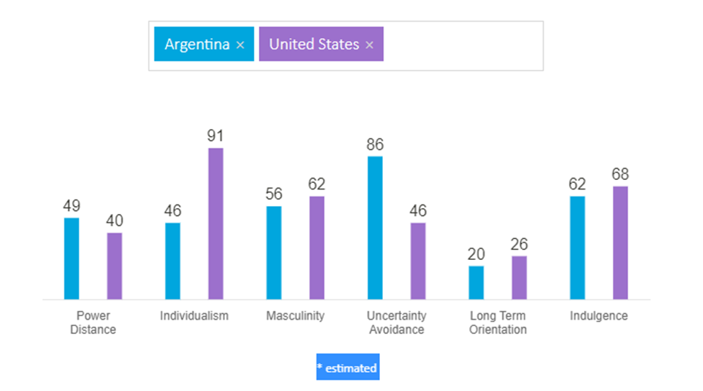
Cultural and Administrative distances to consider:
Cultural:
- Communication in the U.S. is more direct verbally with less body language.
- Communication in Argentina is emotive, being more personal and personal space is not limited.
- Values in the U.S. are individualistic, independence and self-determination.
- Values in Argentina are friendly, hospitable, loyal and committed to family.

Administrative:
- Regulations in the market can be strict and expensive in the U.S. compared in Argentina.
- Opportunity and recognition are high in the U.S. compared in Argentina.

Industry Analysis:
We conducted an Industry Analysis in Week 4 using the PESTLE analysis. This provided key information on suggesting to the client which direction to take.
Industry Definition:
- The industry is Sports Medicine that makes products for athletes and athletic clubs or gyms. Sports medicine is an 8.7 billion industry worldwide that has a growth rate of 8.7%. Licensed coaches, athletic trainers, physical therapists, and athletes are the major players in this industry.

Industry Context:
- Political: The industry has impacts on employment, financial markets, the natural environment, and the well-being of the population. Need to be able to have FDA approval and medical classification on certain devices.
- Economic: The industry is impervious to being influenced by economic cycles. The rise in sport related injuries, continuous influx of new products and treatments, and the rising demand for minimally invasive surgeries are the main drivers of demand for the industry’s products. COVID-19 made profits decrease. Hiring licensed professionals can be costly.
- Social: Popularity in sports affects the demand in the sports medicine industry. The younger generation are adapting to a healthier and active lifestyle that also affects the demand in the sports medicine industry.
- Technological: the sports medicine industry is always using innovation to improve on preventing sport injuries or to increase the time of rehabilitation of sport related injuries. Innovative products are the most attractive products to be made and sold in the sports medicine industry.
- Environmental: High usage of electricity and power consumption to use the products are the major impacts of the sports medicine industry on the natural environment.
- Legal: Patents, trademarks, and copyrights are very important in the sports medicine industry, because these are what encourage and protect important innovations and mechanisms that power the sports world. Most firms in the sports medicine industry depend on patents, trademarks, and copyrights in order to make a profit.

5 Forces + Complementor:
- Buying Power, Complementor Power, and Competitive Rivalry are high in importance.

Prevailing Business Models:
- Customer value proposition consists of offering high quality products and great service. Customizing products to athletic needs to prevent sport related injuries. Companies can make money by low-margin-high-volume sales. Popularity of a product can increase sales.

There are many Factors that are included in the industry analysis, some of which are economics trends, social and political factors, changes in technology and the rate of which they change at. the overall attractiveness of the industry; and other critical determinants that can guide Free Motion to have future success.

Similarities among the industries include:
- Expertise among educated professionals is a big, helpful commonality. This will be easily transferable to help move Free motion
- The Government is very welcoming to startups and new business into the industry. In fact, they offer several potential grants and crowd funding to qualified organizations to further promote innovation
- Product differentiation is what makes your product or service stand out to your target audience. It's how you distinguish what you sell from what your competitors do, and it increases brand loyalty, sales, and growth. Focusing on your customers is a good start to successful product differentiation.
- Patents, trademarks, and copyrights are very important! These methods of protecting your intangibles while publicly providing notice to other businesses to avoid copying or infringing on your intellectual property are highly encouraged
Problematic differences we believe will create hurdles are:
- Entry into the US market has significant cost disadvantages. It’s going to require a large amount of funding in order to properly enter and staple your product to solidify your name & Brand as a leader and number one choice for ankle rehabilitation
- A large social media Prescence from a marketing perspective and sport affiliations is a MUST HAVE in this industry. This helps with promoting your product & brand
- Economies of scale lead to increased profits, generating a higher return on capital investment and providing businesses with the platform to grow on a larger scale. With this being said, through our research we found that North America is projected to have the largest growth in the industry over the next 7 years, however, this brings us to your next challenge which is Industry Intensity & rivalry among competitors. If we are able to find this information, then organizations like Johnson & Johnson, Medtronic, Pfizer and Procter & Gamble
- Marketing, Past Sales, & Earnings Performance are Very Important, as a new startup with only a patent pending prototype without any physical sellable product units, may send the wrong message to potential customers and users in the industry.

Target market (Universities) & WHY:
Free Joint Motion will gain greater access to cutting-edge research and scientific talent at a time when corporate R&D budgets are nonexistent or increasingly under pressure. Universities can gain you financial support and partners in research at when government funding is shrinking or unavailable. Partnerships are an important part of a startup's market development strategy. They help to ensure that your company has a product that will appeal to your target market. It also enables you to integrate your value chain and create a whole product solution. With that being said, companies including Amazon, Facebook, Google, and Uber are using universities as a key part of their early-stage innovation and new ventures strategies which shows how valuable these relations can be and the value they bring.
Now that we have identified the “Why Universities” Here are our recommend Universities for you to approach and potentially partner and collaborate with. (Please refer back to our PowerPoint presentation uploaded on Basecamp, slide “7” for the list of potential partners). We believe your number one option should be University of Southern California, USC Has the Stevens Center for innovation which allows external startups like Free Joint motion to join their institution which in return, will give you access to all their partnerships and affiliations. These joint venters and mergers will help build a network with industry leaders, create access to capital, and to cutting-edge workforce development and education programs. They also provide emerging entrepreneurs like yourselves with facilities, resources, training, and knowledge to launch your startup in the North American market which will spur regional economic development. This is a win-win option for Free Joint motion given the current budget and resource restrictions

Funding:
When looking into funding, we wanted to be sure that there were plausible options available to start-up physical medicine product companies much like “Free joint motion”. The first option we found was the foundation for Physical Therapy Research. They are a foundation that will be awarding up to $500,000 in research grants in 2022 alone. A link to their website can be found below where you will find their application. It is free to apply for this grant and after doing some additional research, we believe Free Joint Motion will qualify. Another option is the Foundation for Physical Medicine Research who also offers a variety of research grants. The application process for these grants is simple but can be time consuming. We understand that time is valuable, and highly recommend applying to the Foundation for Physical Therapy Research if you were to only pursue one grant.
Another strong option would be attending conferences such as the American Conference of Rehabilitation Medicine. The link to this conference can be found in our sources section. These types of in-person events not only allow us access to the latest research, an opportunity network with colleagues from around the world, but also have access to potential funding opportunities such as investors. It would also be a great opportunity to see what the competition is up to. These conferences do cost money to attend, however the possibilities of making networking connections can be extremely lucrative for the company.

Barriers to Entry:
FDA approval for any product is an obstacle that could restrict a company from entering into the United States market. It is crucial that we complete our due diligence and know what to expect. After some research, we believe that Free Joint Motion can be identified as a Class I product. While we are aware that some may argue that it is a class II product, we have done extensive research and can confidently say that this is can be approved as a Class I product. We compared Free Joint Motion’s product to other similar products by using the FDA’s “Product Code Classification Database” in order to come to this conclusion.
According to the FDA, Class I products “present minimal potential for harm to the user and are often simpler in design and less invasive than class II or III devices”. Class I devices are typically the fastest and easiest to bring to the market and are sometimes exempt from some requirements such as Premarket approval which is beneficial for the company. Regardless of that, Class I devices still must adhere to the FDA General controls. The FDA has general controls for medical devices that ensure their safety and effectiveness. This list can be found linked below in our sources section. Mainly, it is crucial that Free Joint Motion ensures that the product is ready to be marketed properly and is safe and effective.

Pricing Model:
There are different pricing strategies to figuring out how to price your model, however, there are some examples that have the best benefits and fit with Motion's goals.
Penetration pricing is ideal in a market with numerous similar products and customers sensitive to price, a significantly lower price can make your product stand out. This strategy is generally used by new entrants into the market. You can motivate customers to switch brands and build demand for your product. As a result, that increase in sales volume may bring economies of scale and reduce your unit cost.
Value-based pricing is the perceived value to the customer is primarily based on how well it’s suited to the needs and wants of each customer. The first and top advantage of using value-based pricing is the increased value of the brand. Offering products that stand out in the market and will help better convey the uniqueness that the product. It allows for increased profits and customer loyalty.
And lastly, a good suggestion would be exchanging a competitor's older product and offering your new product at a discount, which can entice and keep customers interested.

Market Size:
Key factors that drive the market growth include a rise in incidences of injuries associated with sports, an increase in adoption of sports activities by people, and growth in demand for minimally invasive treatment methods. Thus, the rise in incidences of sports injuries worldwide propels demand for market growth. Also, government initiatives for the sports industry are continuously liable for expansion of the market.
Through our research we found that the global sports medicine market size is estimated at 8.7 billion and forecasted to reached 15.2 billion by 2027 with an expected growth rate of 8.2%. The global rehabilitation equipment market size is estimated at 10.53 billion and is expected to grow at a 6.0% growth rate during the forecast period. In the Sports Medicine Market, Body Sport & Recovery segment would be perfect for entry along with along with the Rehabilitation Market, Mobility Segment. We feel that Free joint motion can take advantage of both markets as your product fits perfectly in both with no additional product designs and or differentiation. This will provide you with a bigger market opportunity that will lead to a larger captured market share for Free Joint Motion.

Conclusion:
Performing extensive research on the client, their goals, the type of market or industry, and how to enter the market is what we provided in our projects and final presentation. Putting all the research that was performed together and condensing it in our assignments helped us with choosing and presenting the final suggestions to the client. Identifying the main scenario, CAGE analysis, Industry analysis, and Market size and opportunity aided us to provide the client with our suggestions or recommendations on how to enter the market with fewer obstacles. The more research we did, the clearer it became about what to suggest and how to the client.
We suggested following the steps on how to enter the market.
- Step 1: Grants
  - Looking into grants is the first step that is helpful in providing the needed costs with marketing your product.
- Step 2: Focus on a University
  - Focusing on a university of your choosing will also provide the support you need to enter the market.
- Step 3: Pricing Model
  - After going through steps 1 and 2, this will help you determine how to price your model in the market.
- Step 4: Enter the Market
  - From steps 1 to 3, entering the market would be less difficult and you can finally promote your product and business.

Sources:

https://foundation4pt.org/grants
https://conference.acrm.org/
Ghemawat, P. (2001). Distance still matters: The hard reality of global expansion. Harvard Business Review, 1-11.
Simpson, S. D. (2021). A Checklist for Medical Technology Investments. Investopedia. https://www.investopedia.com/articles/stocks/08/medical-tech-investment.asp
https://www.hofstede-insights.com/country-comparison/
Mindtools. (2013, June 11). PEST analysis: Identifying the “big picture” opportunities and threats. https://www.mindtools.com/pages/article/newTMC_09.htm
CGMA. (2013, June 11). Porter’s five forces of competitive position analysis. https://www.cgma.org/resources/tools/essential-tools/porters-five-forces.html
https://sloanreview.mit.edu/article/developing-successful-strategic-partnerships-with-universities/
https://stevens.usc.edu/usc-startups/external-resources/
https://www.fda.gov/medical-devices/regulatory-controls/general-controls-medical-devices
https://www.bdc.ca/en/articles-tools/marketing-sales-export/marketing/pricing-5-common-strategies
https://corporatefinanceinstitute.com/resources/knowledge/strategy/penetration-pricing/
https://www.marketing91.com/value-based-pricing/
https://www.grandviewresearch.com/industry-analysis/sports-medicine-industry#:~:text=The%20global%20sports%20medicine%20market%20size%20was%20estimated%20at%20USD,USD%208.7%20billion%20in%202020.
https://www.businesswire.com/news/home/20220607005987/en/The-Worldwide-Sports-Medicine-Industry-is-Projected-to-Reach-12.8-Billion-by-2030---ResearchAndMarkets.com
Epps, T. (2020). Sports Medicine Careers. Best Colleges. https://www.bestcolleges.com/careers/healthcare/sports-medicine/
https://medicalfuturist.com/future-of-sports-medicine/
https://www.globenewswire.com/en/news-release/2022/03/31/2413933/0/en/Sports-Medicine-Market-Regenerative-Medicine-are-major-Factors-Driving-the-Market-MDC-Research.html

